**Upstream and Downstream projects**

* If the project A triggers the Project B, then
  + Project B is downstream of Project A
  + Project A is upstream of Project B  
    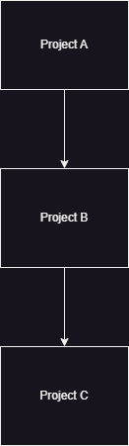

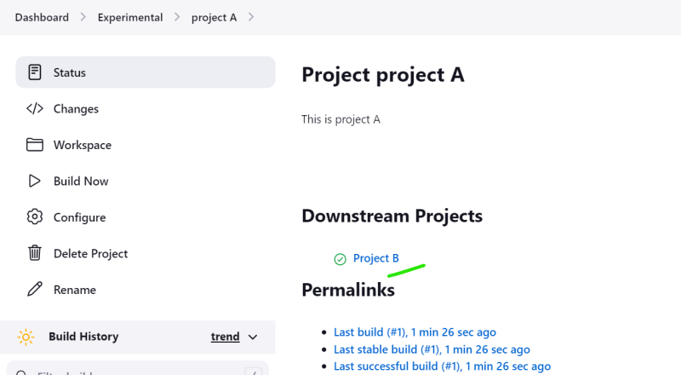  
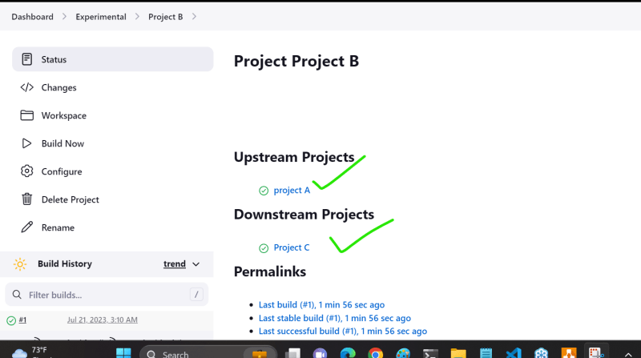

**Parametrized Builds**

* While building the jobs, sometimes we would like users to pass some information.
* This is called as parameters
* Lets enable parameters for some jenkins project/job  
  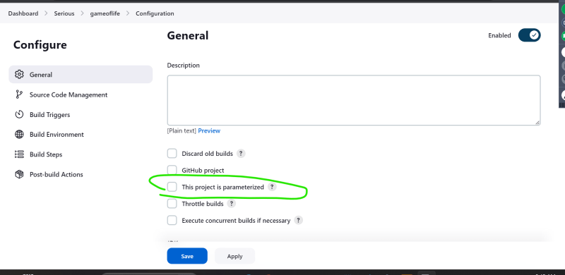  
  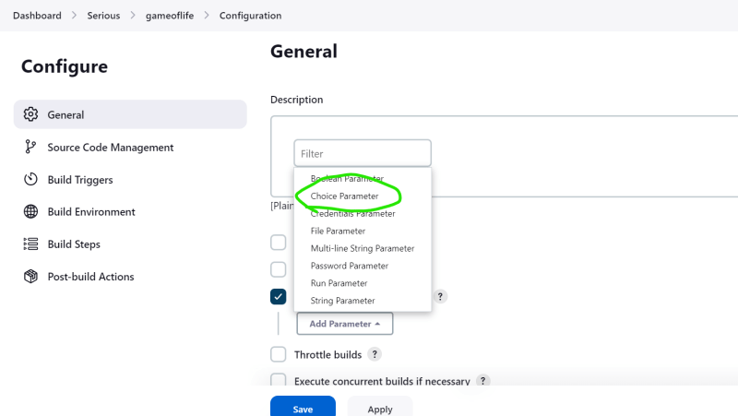  
  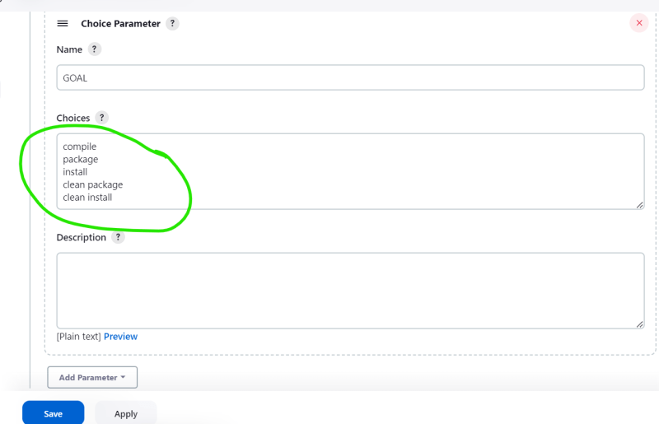  
  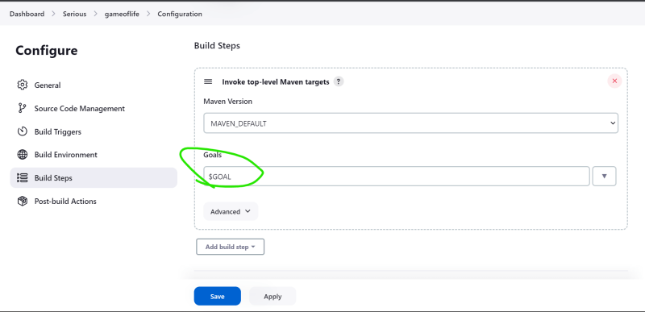  
  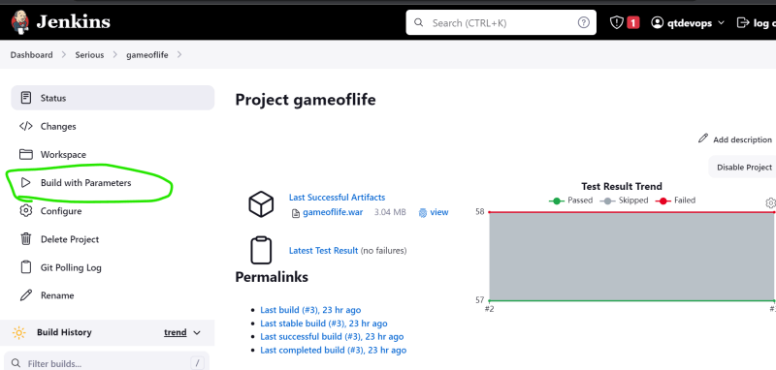  
  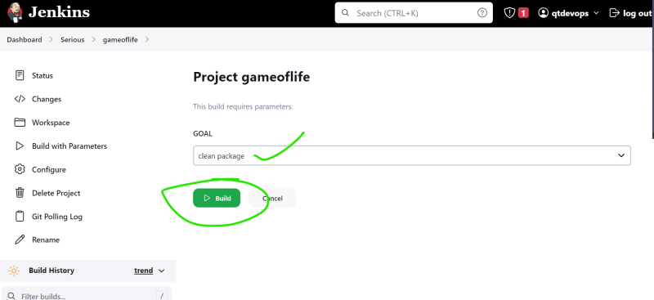  
  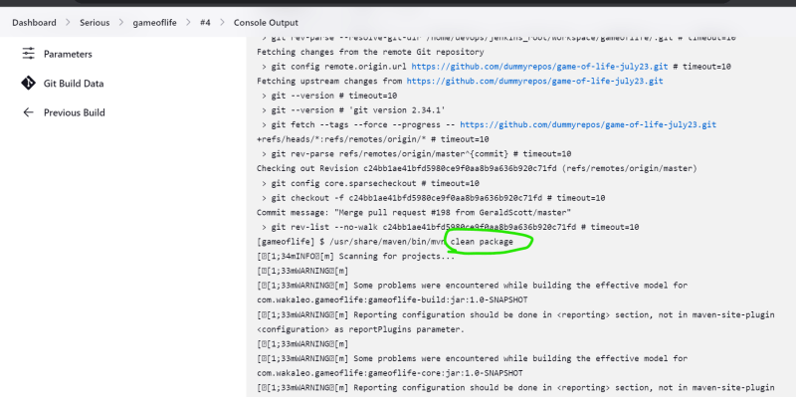

**Jenkins Environmental variables**

* Jenkins injects environmental variables into every job in addition to environmental variables present on node
* To view environmental variables Naviage to build steps => execute shell  
  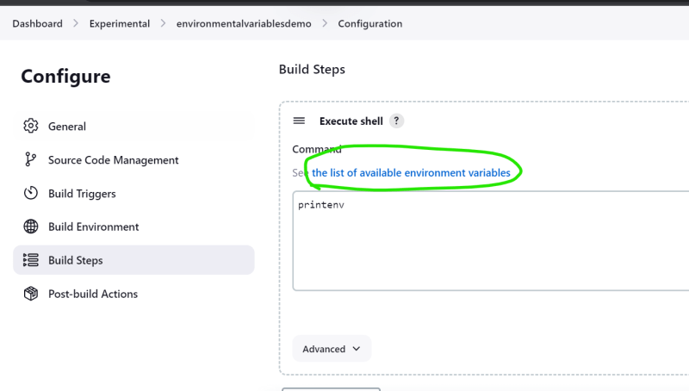  
  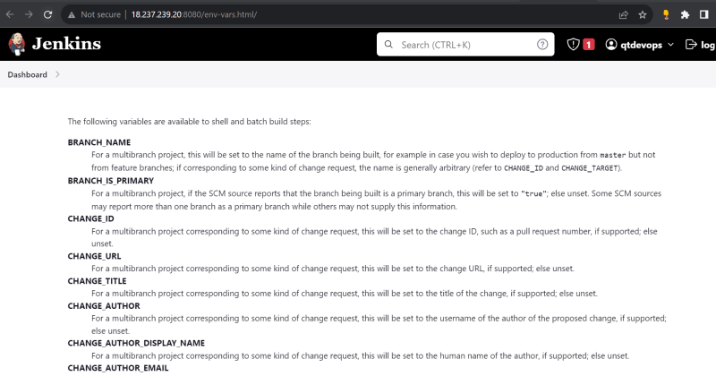
* <https://www.jenkins.io/doc/book/pipeline/jenkinsfile/#using-environment-variables> for docs on environmental variables
* Sample using environmetal variables  
  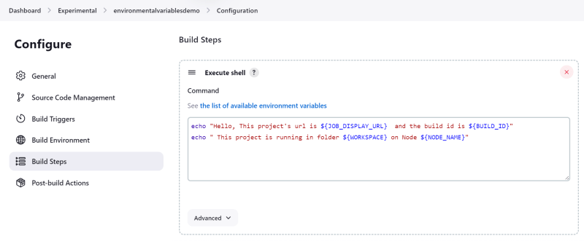
* Result  
  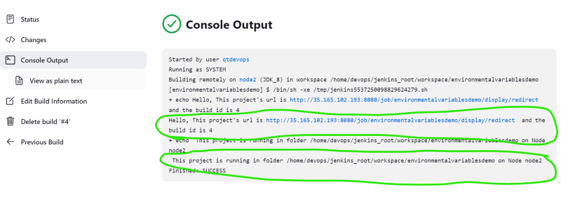

**How to take backup of jenkins**

* One option for backup of configuration files  
  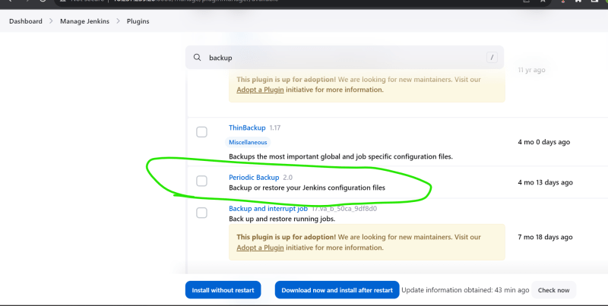  
  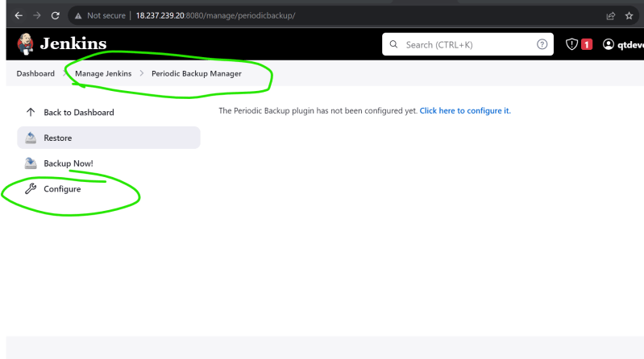  
  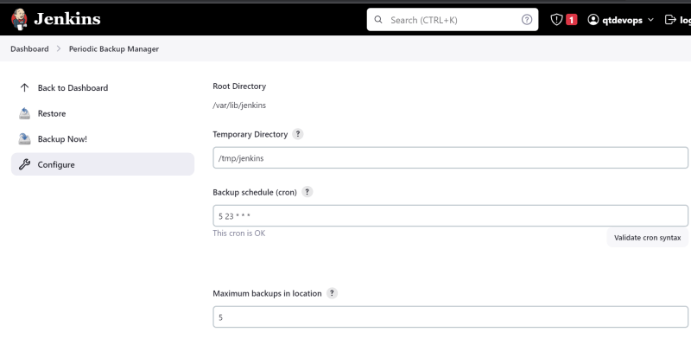  
  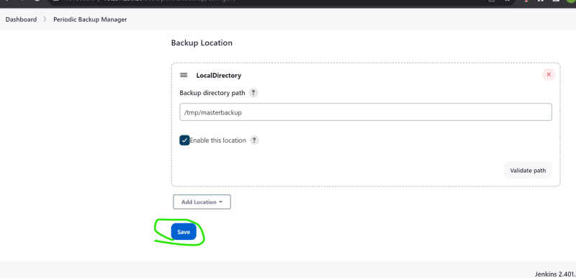

**Which plugin should be installed to monitor jenkins**

* <https://plugins.jenkins.io/monitoring/>   
  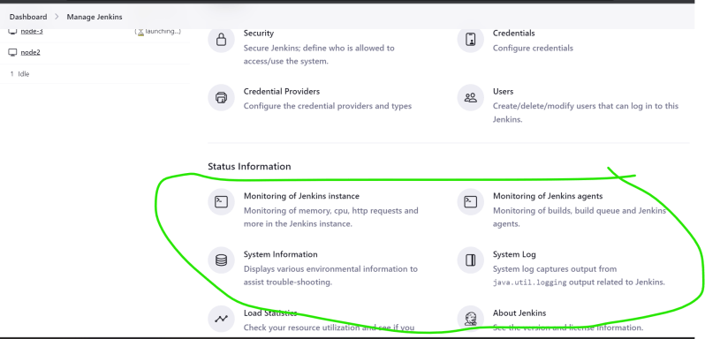
* Jenkins Plugins can be installed from
  + Market place
  + Uploading the plugin
* Jenkins plugin has two extensions
  + jpi (Jenkins plugin interface)
  + hpi (hudson plugin interface)